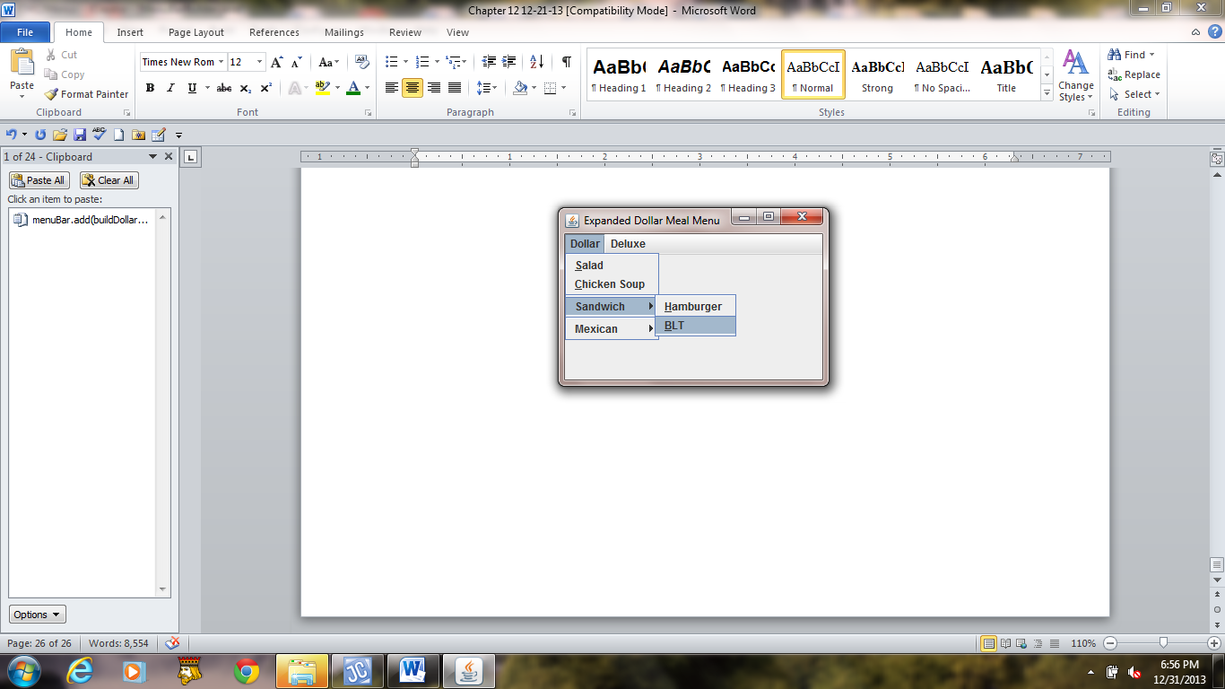

**Figure 12.12 A drop down menu system that contains two submenus.**